Info Security

Assignment 1 SQL Injection Attack

Muhammad Usman Noor

231-462066

Steps:

I did SQL injection attack on website “vulnweb.com” using sql map command I performed the attack fetched email and phone number of the users

The first command was as follows:

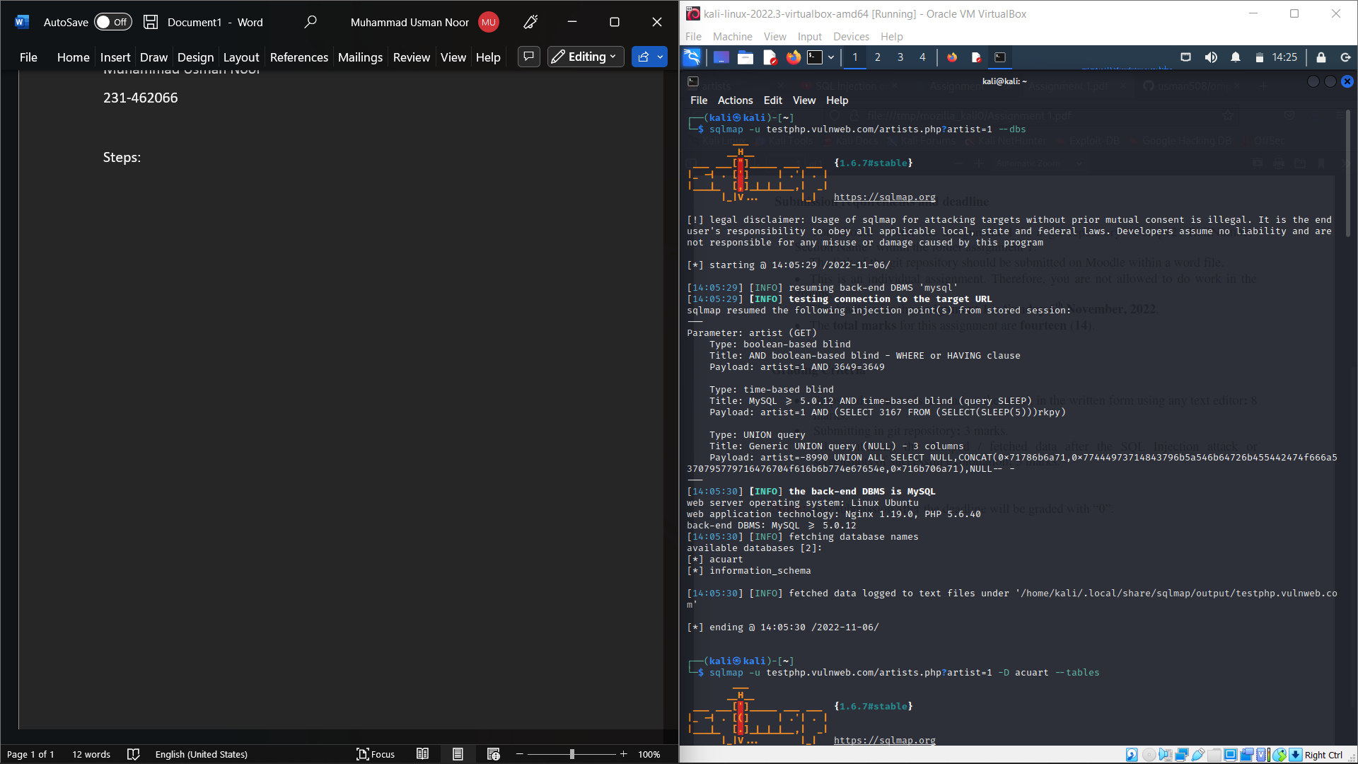

Which fetched me the database of the given website.



After which I fetched the tables using command:

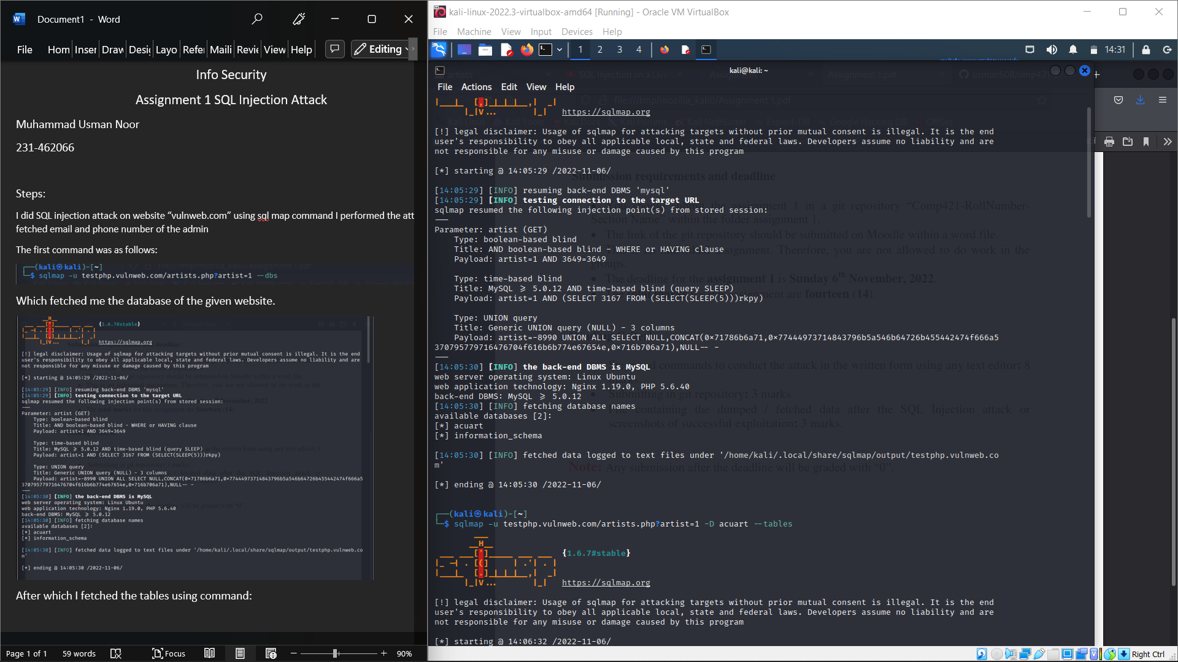

Which fetched me tables:

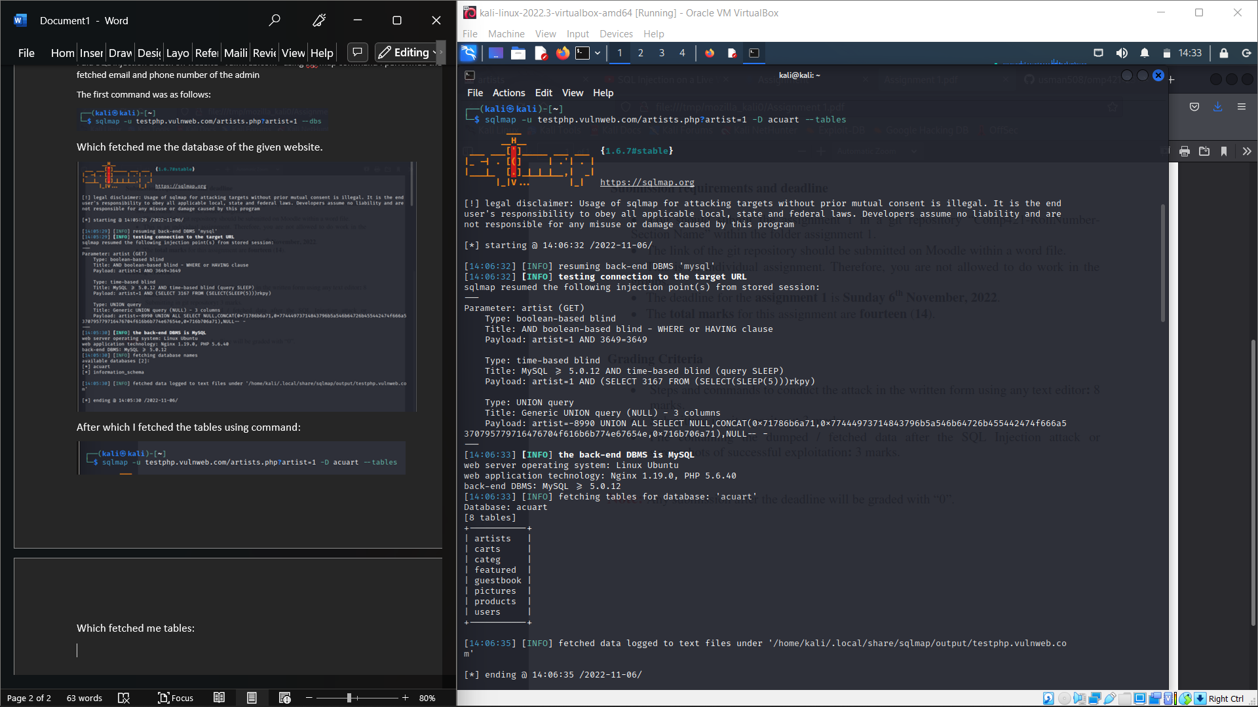

After which I fetched users using command: 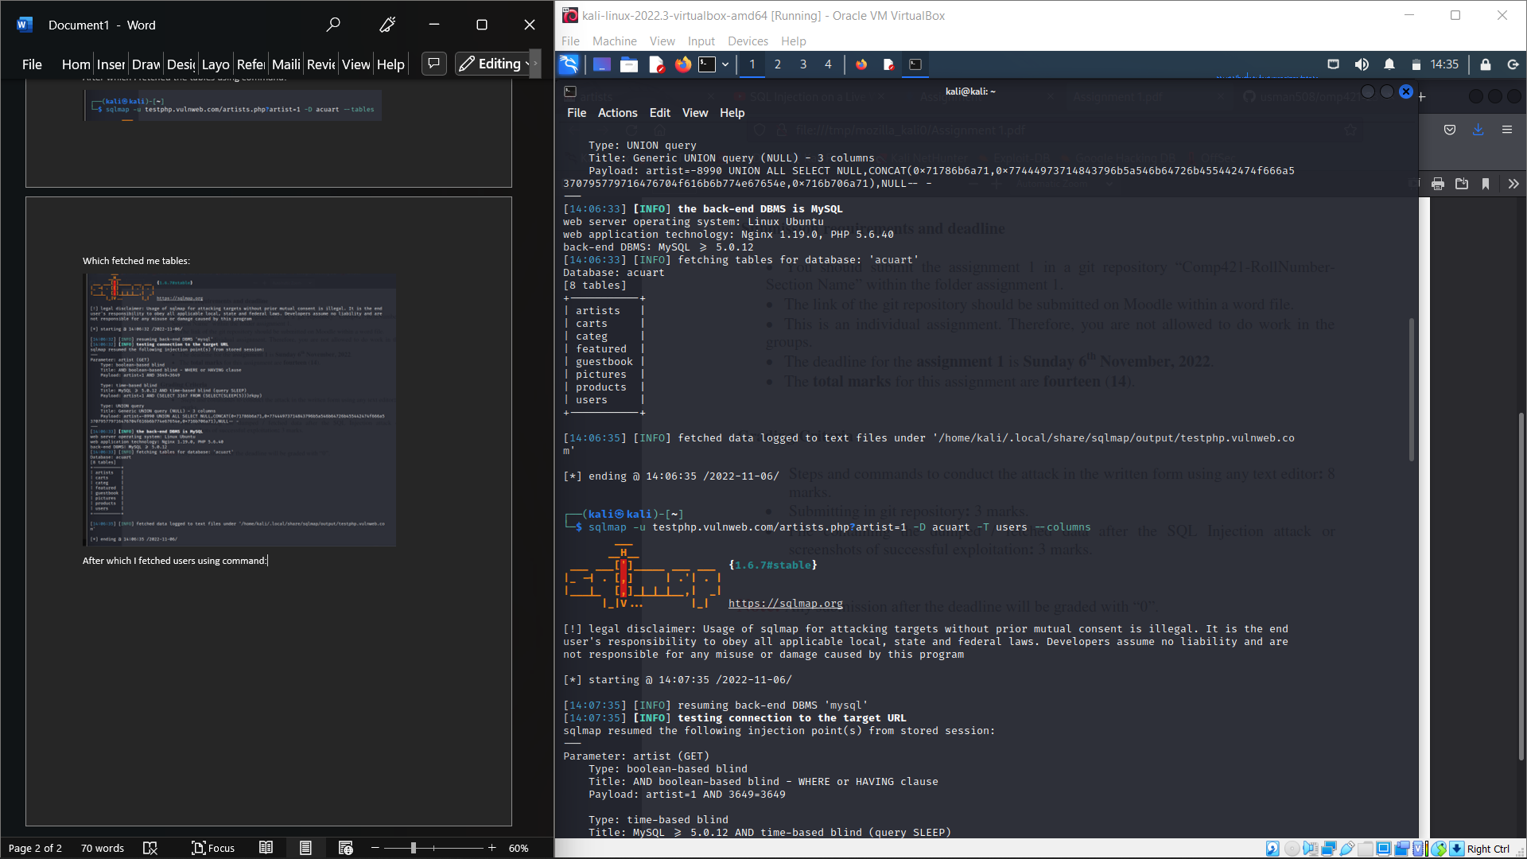

Table users had following credentials: 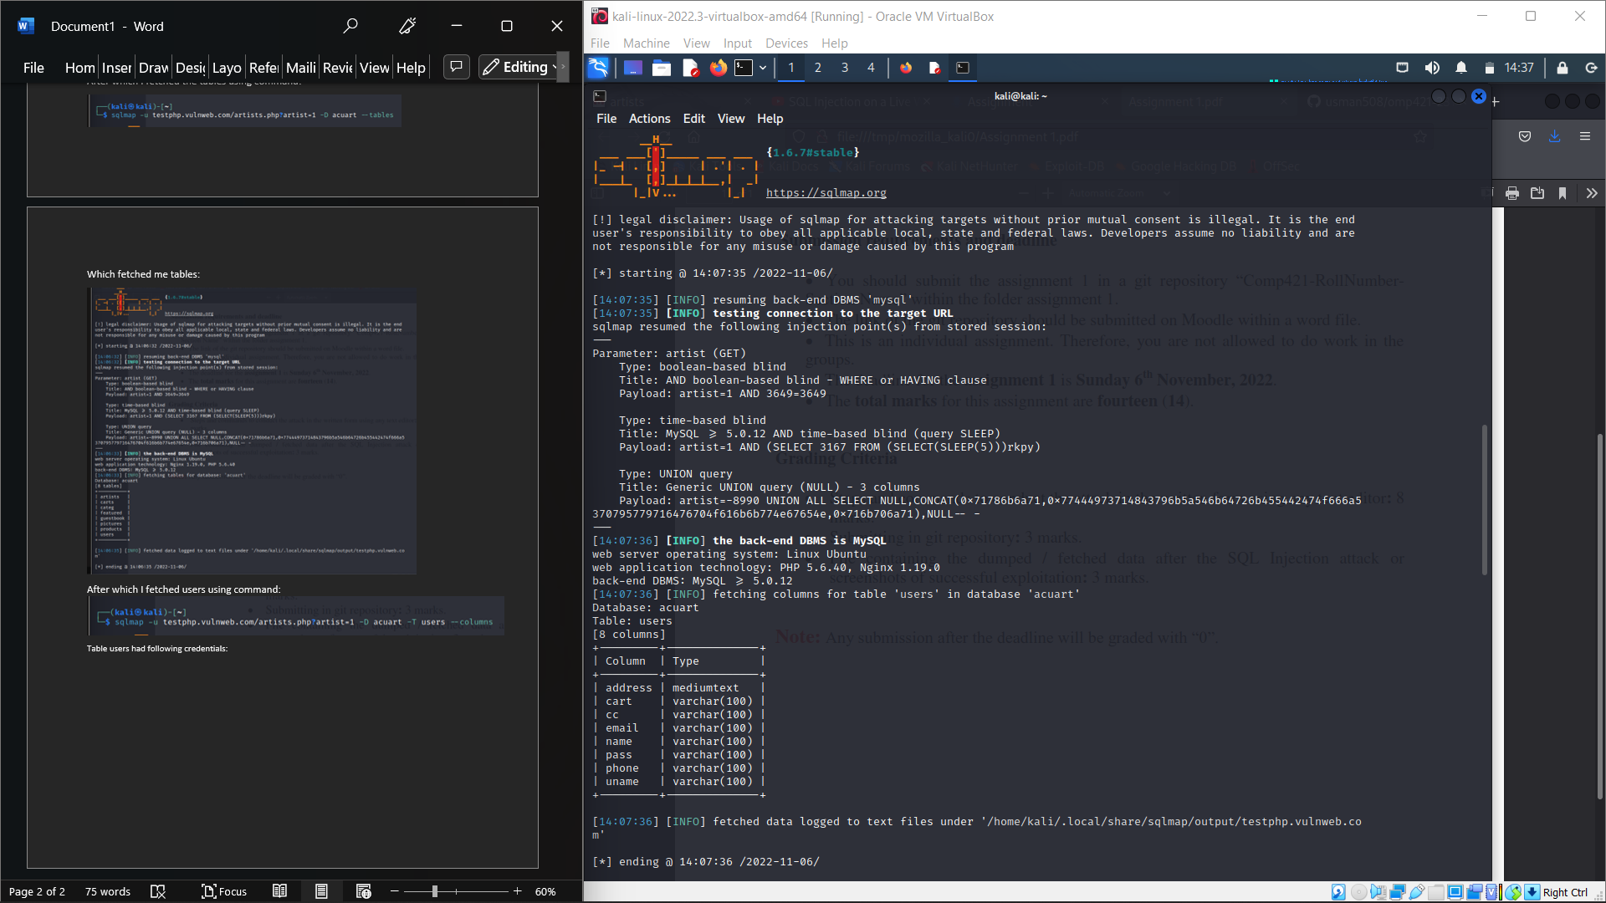

From where I fetched email and phone number: using commands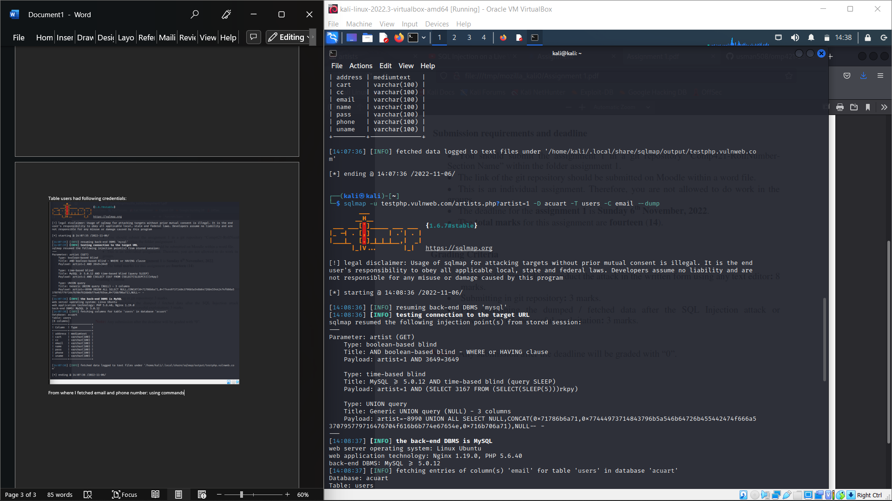

It gave me phone number and email :

